A.A.GOVERNMENT ARTS COLLEGE,MUSIRI
Affiliated to Bharathidasan University, Tiruchirappalli

NAAN MUDHALVAN PROJECT -III BSC MATHEMATICS

TOPIC:
POLITICAL JUGGERNAUTS: A QUANTITATIVE ANALYSIS OF CANDIDATES IN THE 2019 LOK SABHA ELECTIONS

Submitted by
TEAM ID:
NM2023TMID08665

TEAM LEADER: P.KEERTHIGA [20468754D3A68818E694E8E312F63BF6]
MEMBERS:
1.D.DHANALAKSHMI [1E9D086A9D7EF03ACF64D72A893AF674]
2. V.DEEPA [28DC3783F3E06A6AAFC44E8CAD0BAA3]

LOK SABHA ELECTIONS 2019
- LokSabha is the house of representatives directly elected by the people. Hence, the LokSabhais called the ‘First House’.
- The members of Loksabha are elected directly by people from the ‘Territorial Constituencies’.
- The Prime Minister is the leader of the LokSabha.
- The first session of this LokSabha commenced on 13 May 2019.
- The tenure of LokSabha is Five Years.
- General elections were held in India in seven phases from 11 April 2019 to 19 May 2019 to elect the members of the 17thLokSabha.
- The LokSabha comprises of a total of 545 seats.
- Elections will be conducted by the Election Commission to fill 543 seats.
- The remaining two seats are filled by nomination of representatives of the Anglo-Indian Community if the President feels that this community has not been represented adequately.
- Votes were counted and the result was declared on 23 May.
- The election result in a landslide victory for the (BJP) which won 303 seats and formed the Government.

EMPATHY MAP
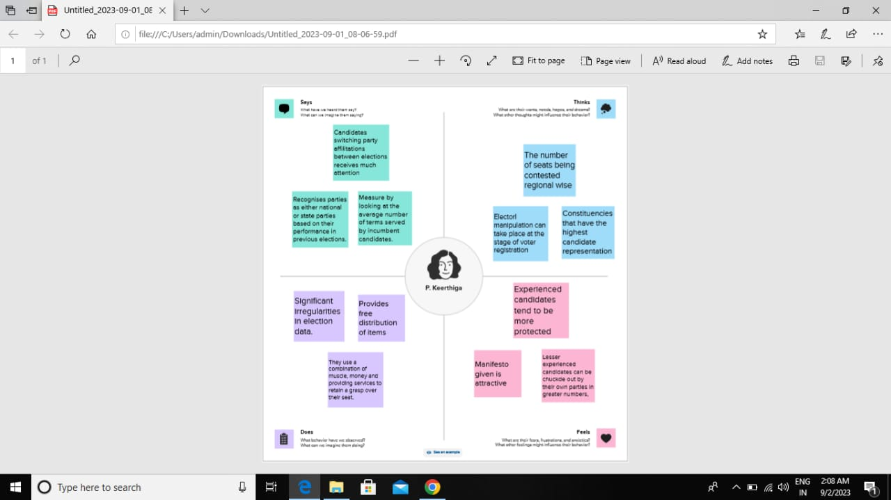
Brainstroming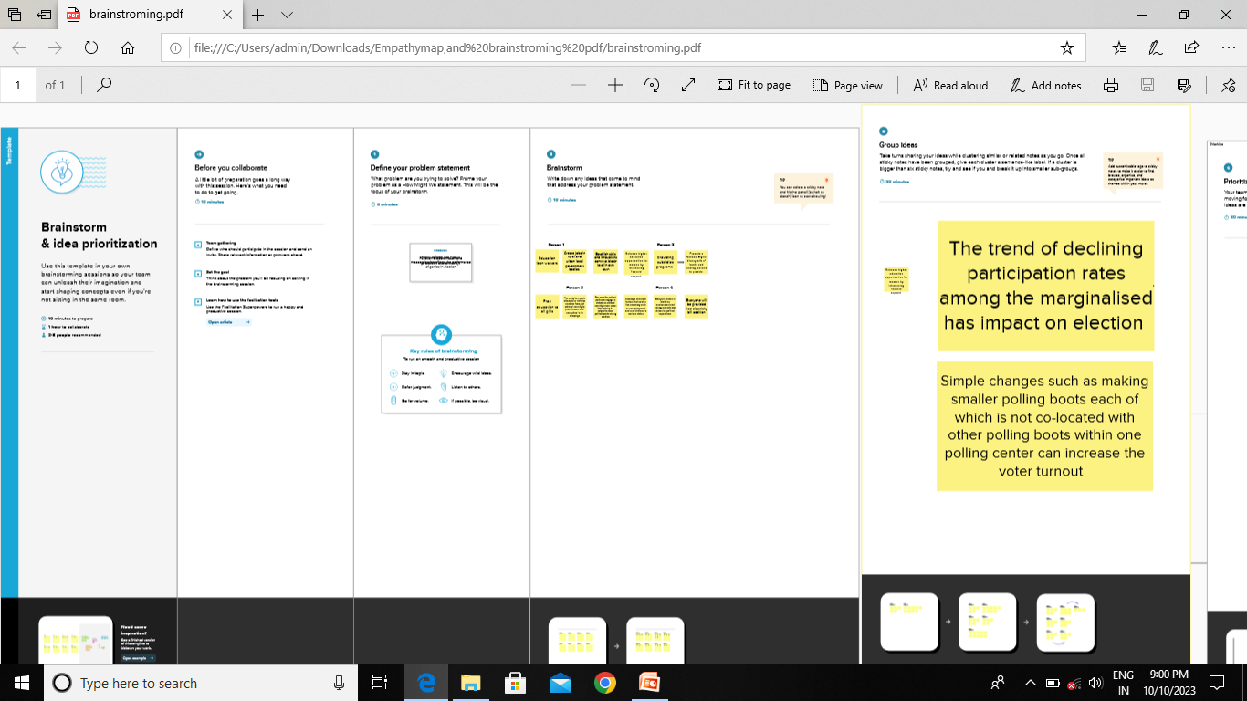

DATA VISUALIZATION
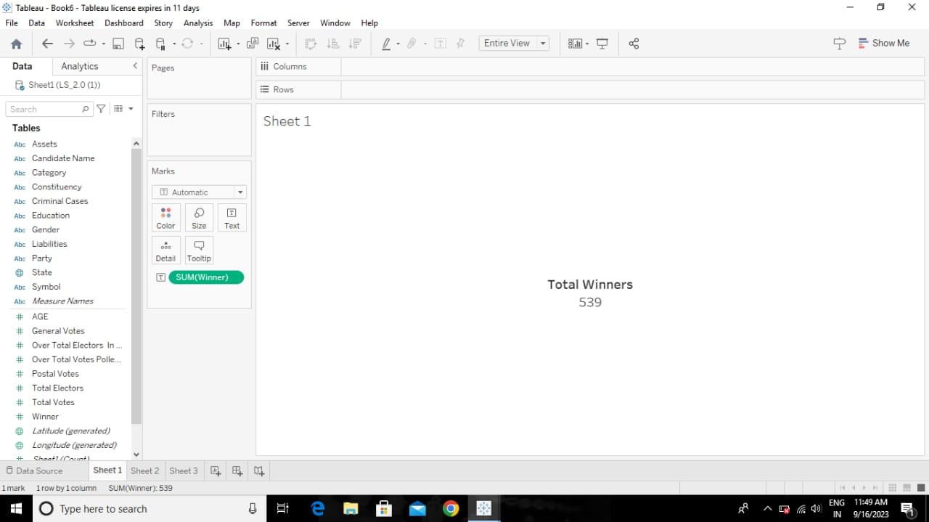
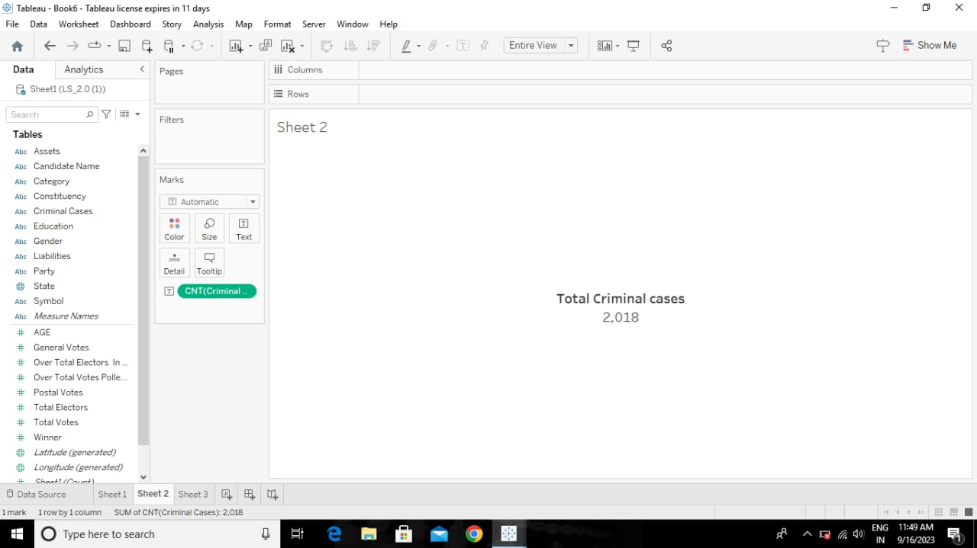

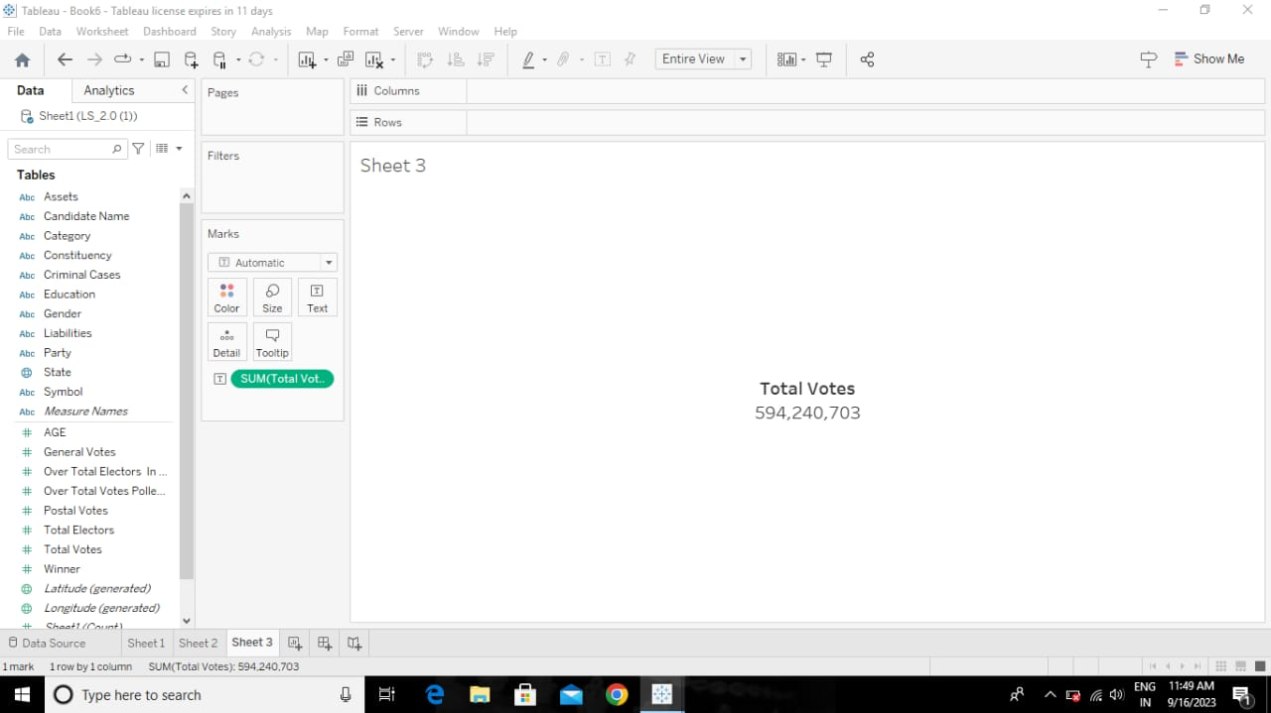
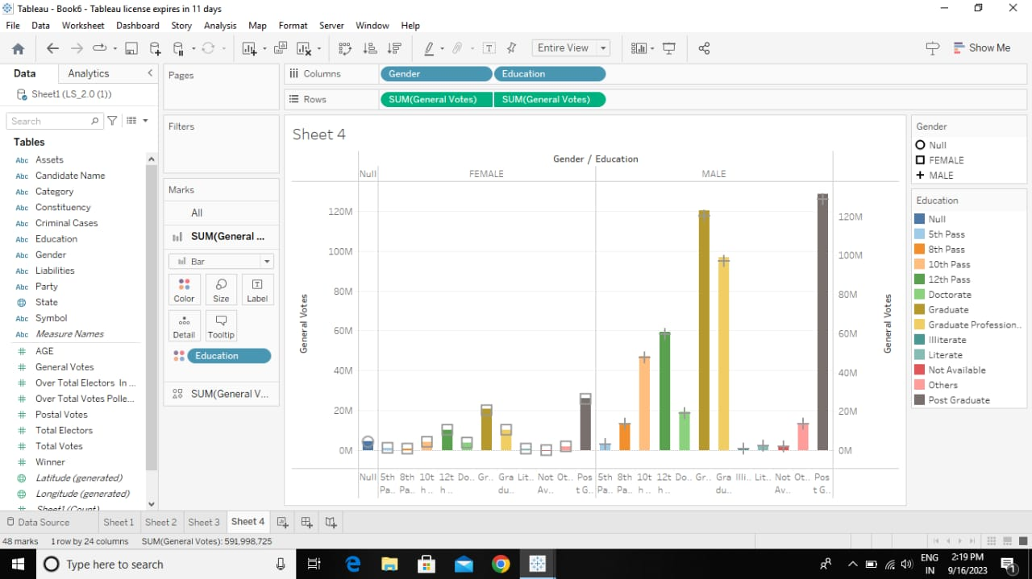

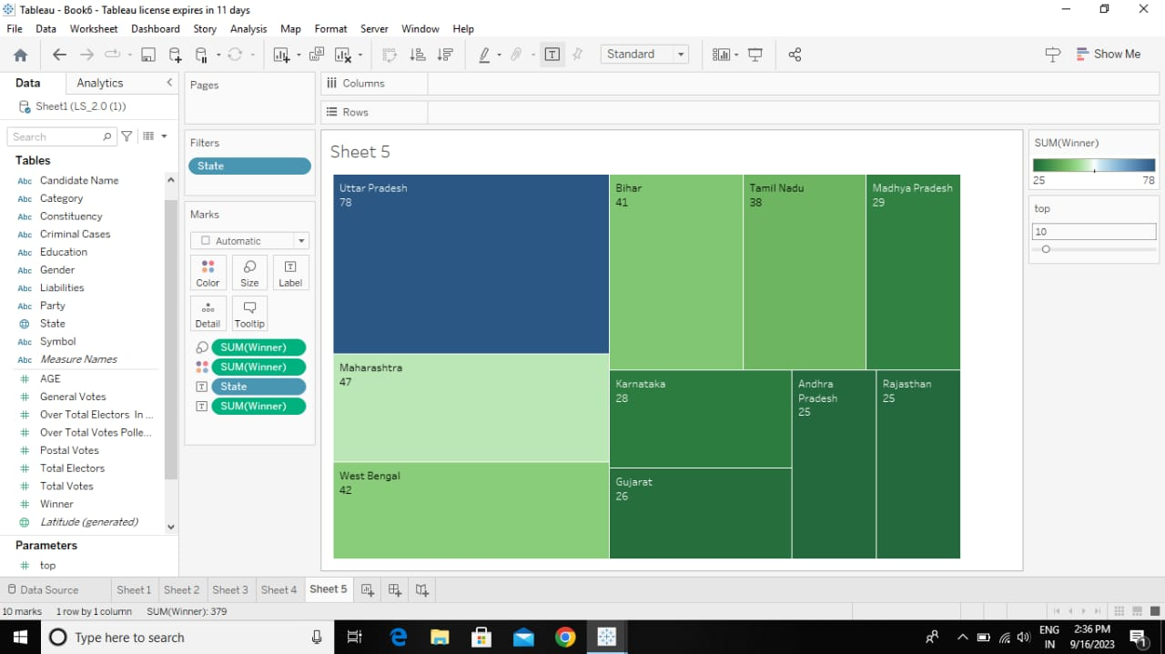
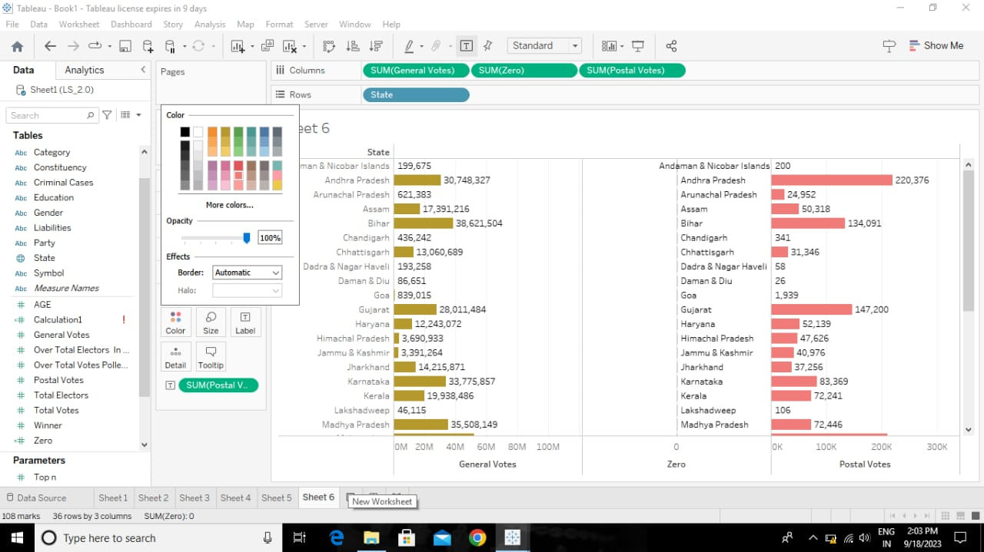

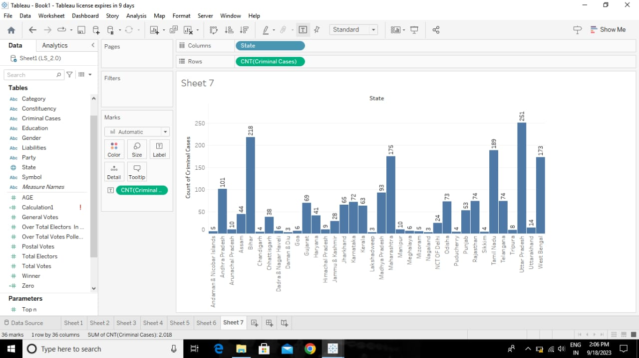
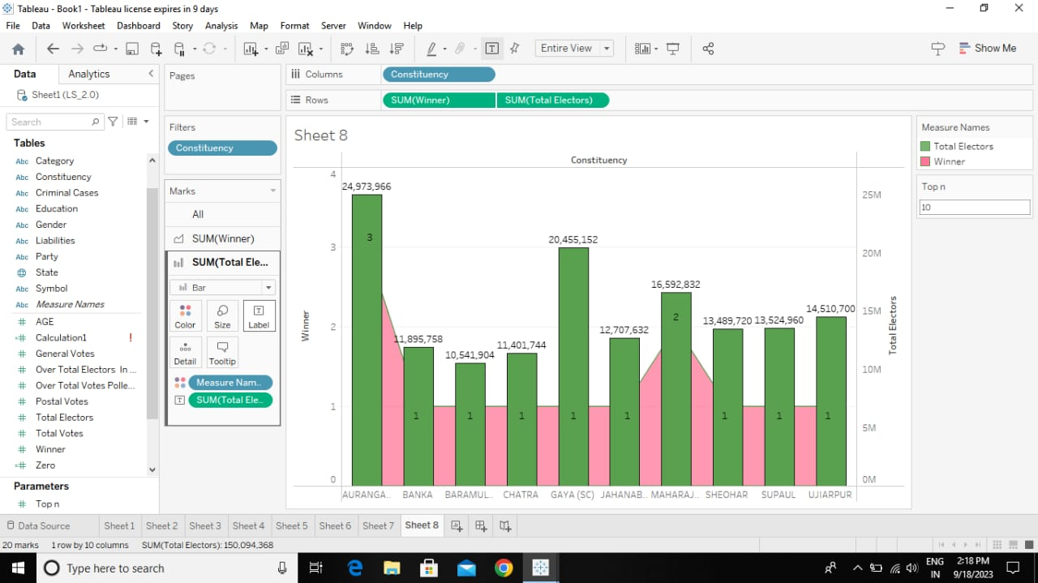

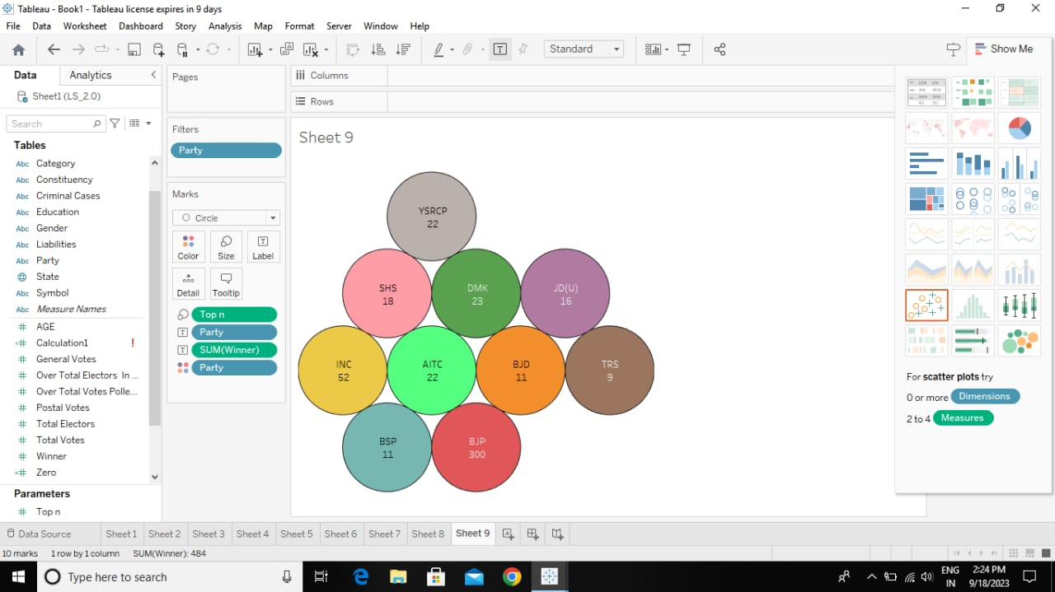
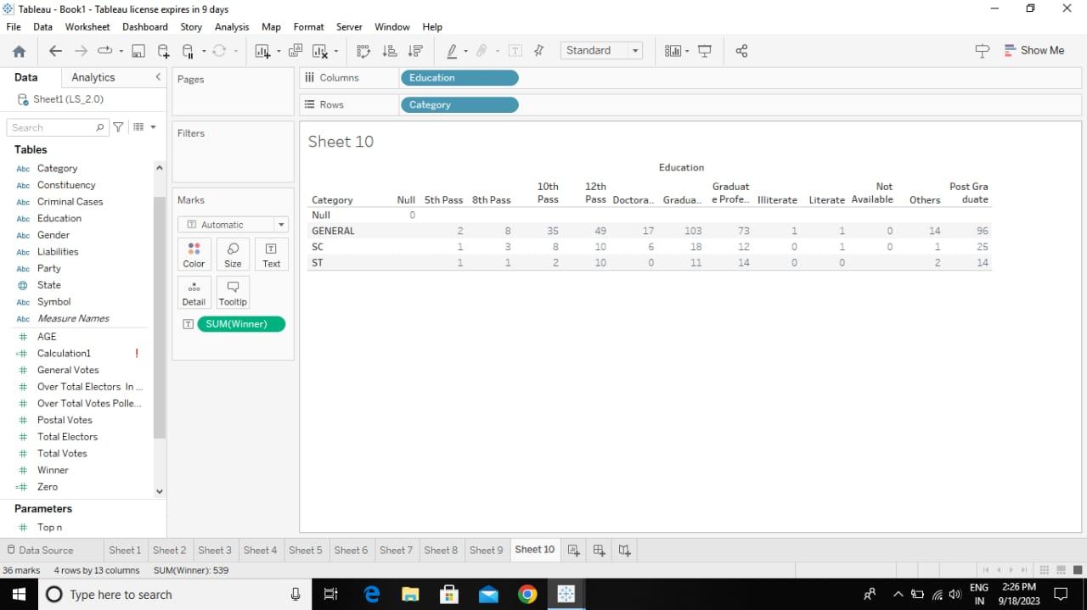
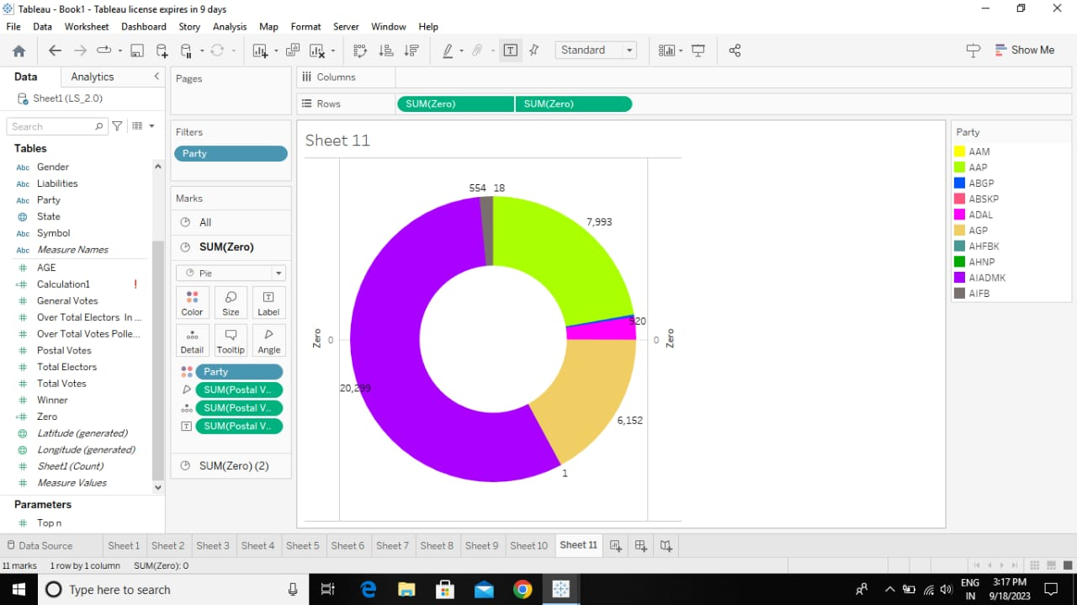

DASH BOARD
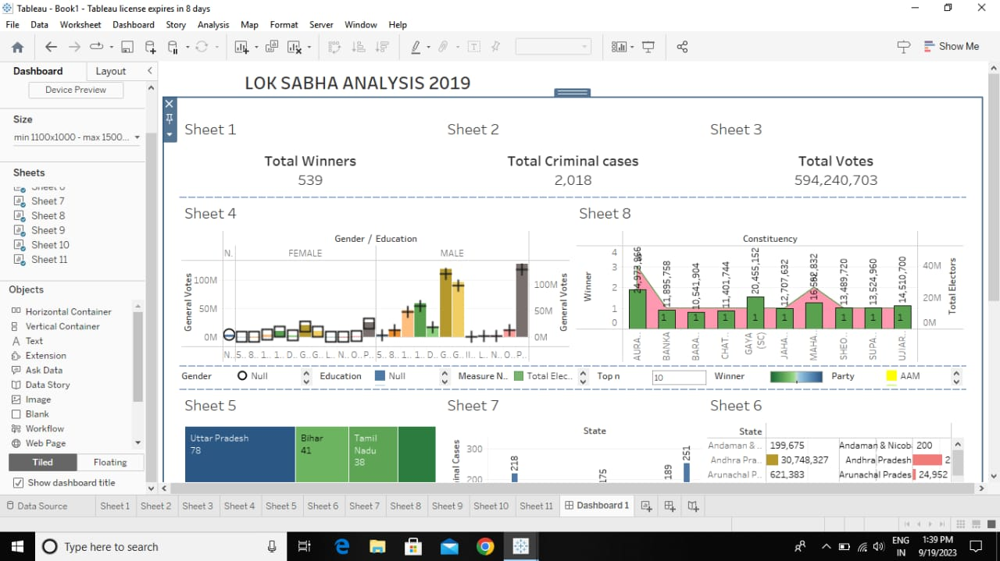
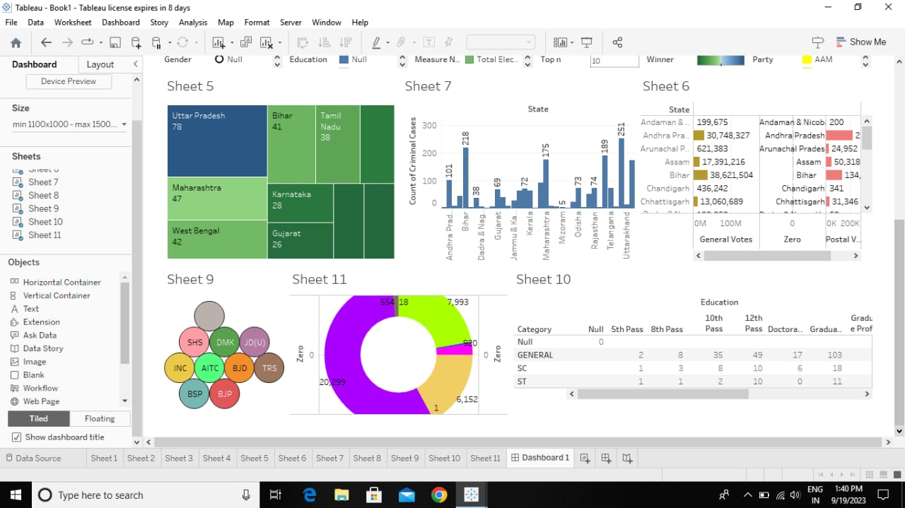
Story